DATABASE SYSTEMS PROJECT

**Group members**

Nimra Zahoor (2019-CS-112)

Sadia Ali (2019-CS-120)

Sania Rashid (2019-CS-107)

Maryam Khan (2019-CS-118)

Ifrah Ahmed (2019-CS-116)

Hasan Ahmed (2019-CS-145)

**Submitted to**: Sir Murtaza Qasmi

**Project Title:**

School Management System

**Description:**

Lahore Grammar School planned to develop a web-based school management system. Admin shall manage the log-in page and students can register themselves through it. The portal shall provide a facility to the admin so he can add/edit students in new sections and subjects. Admin should upload new courses so students will be able to purchase books according to the course. Students could register themselves in different courses. Admin should manage timetable and students should follow that timetable. Admin must have the student’s attendance record. Admin should upload and edit fee challans and students will be able to download fee challans. Admin should manage the online fee portal and parents can submit the dues from that portal. Each subject is taught by a teacher who should add/edit the subject plan, upload materials, lecture notes, helping materials, and assignments, and students can view/download all the material. Admin should mark teacher attendance so chairperson has the record of teacher’s attendance. The Chairperson adds and assigns subjects to teachers. Admin should uploads the results of students. Student should see their assignments. Students must not be allowed to see each other assignments and results for security reasons. The System should provide the backup and security plan.

**Actors:**

* Admin
* Chairperson
* Teachers
* Students

**User stories:**

**1-Admin:**

1. As an admin, I want to manage the log-in page, so that students can register themselves.
2. As an admin, I want to add/edit new sections, so that the students can be assigned different sections.
3. As an admin, I want to add/edit subjects, so that the students can be assigned different subjects.
4. As an admin, I want to upload new courses, so that students can purchase books according to the course.
5. As an admin, I want to manage timetable, so that the students can follow that timetable.
6. As an admin, I want to have the records of student’s attendance, so that parents can view their child attendance.
7. As an admin, I want manage record of all subjects, so that teachers can use it.
8. As an admin, I want to upload fee challans, so that students can download fee challans.
9. As an admin, I want to manage online fee portal, so that parents can submit dues from that portal.
10. As an admin, I want to mark teacher’s attendance, so that chairperson has the record of teachers attendance
11. As an admin, I want to upload the results of students, so that students can view their results.

**Chairperson:**

1. As a chairperson, I want teacher’s history, so I can add and assign subjects according to that.

**Teacher:**

1. As a teacher, I want to add/edit the subject plan, upload materials, lecture notes, helping materials, and assignments, so that students can view and download them.
2. As a teacher, I want to take attendance of students, so that parents can see their child attendance.

**Student:**

1. As a student, I want to register courses, so that I can view/download the study material.
2. As a student, I want to submit my assignment, so that the teacher can see my assignments.
3. As a student, I want to view log-in page, so I can register myself.
4. As a student, I want to view my marks, so that I can print my result sheet.

**Tables:**

Academic details

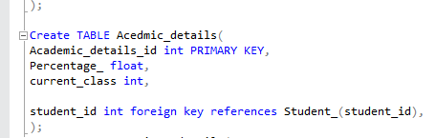

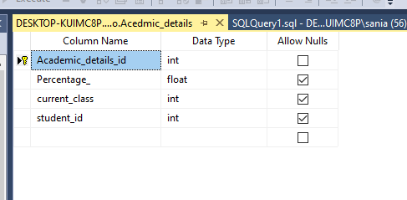

Previous detail:

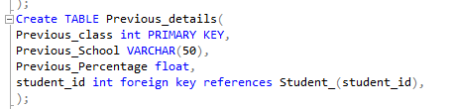

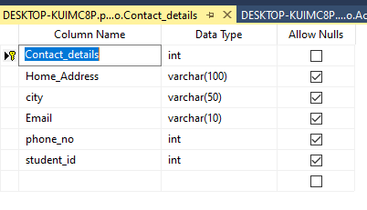

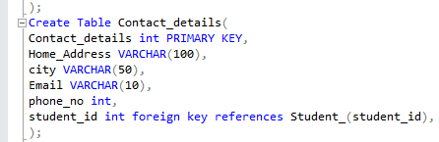Contact details:

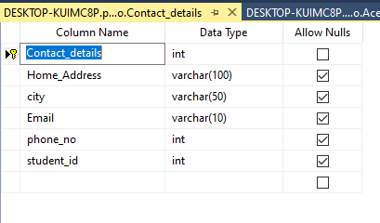

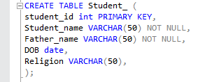Student:

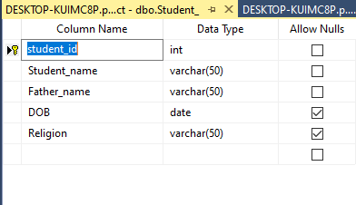

Teacher:

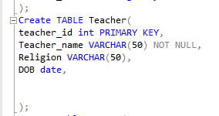

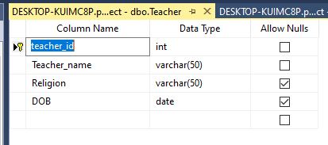

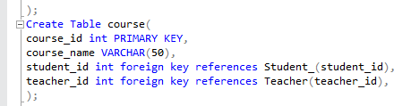Course:

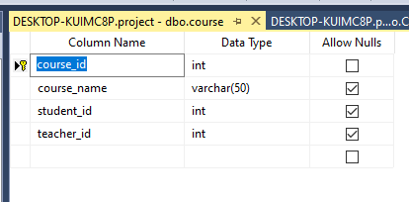

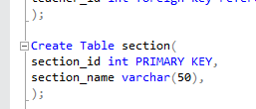Section:

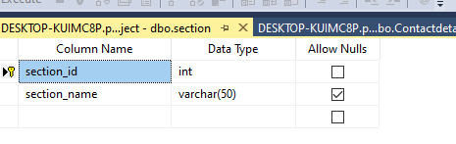

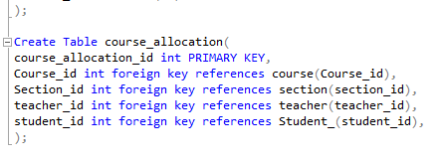Course allocation:

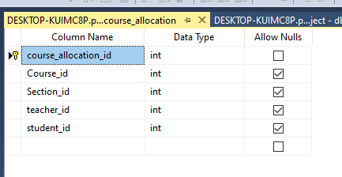

Course registration:

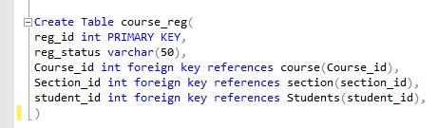

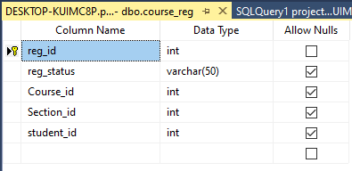

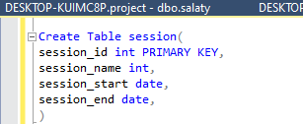Session:

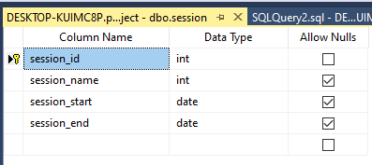

Class:

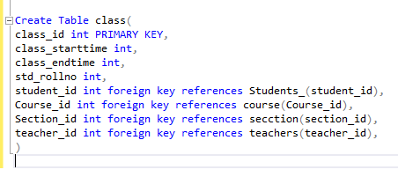

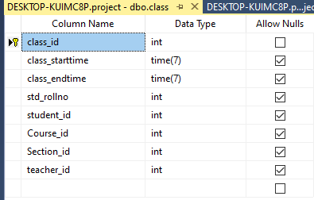

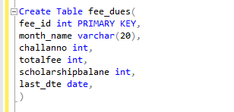Fee dues:

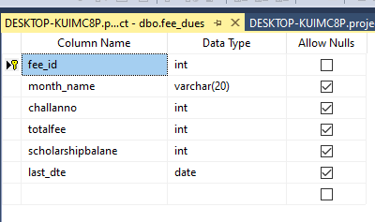

Salary:

